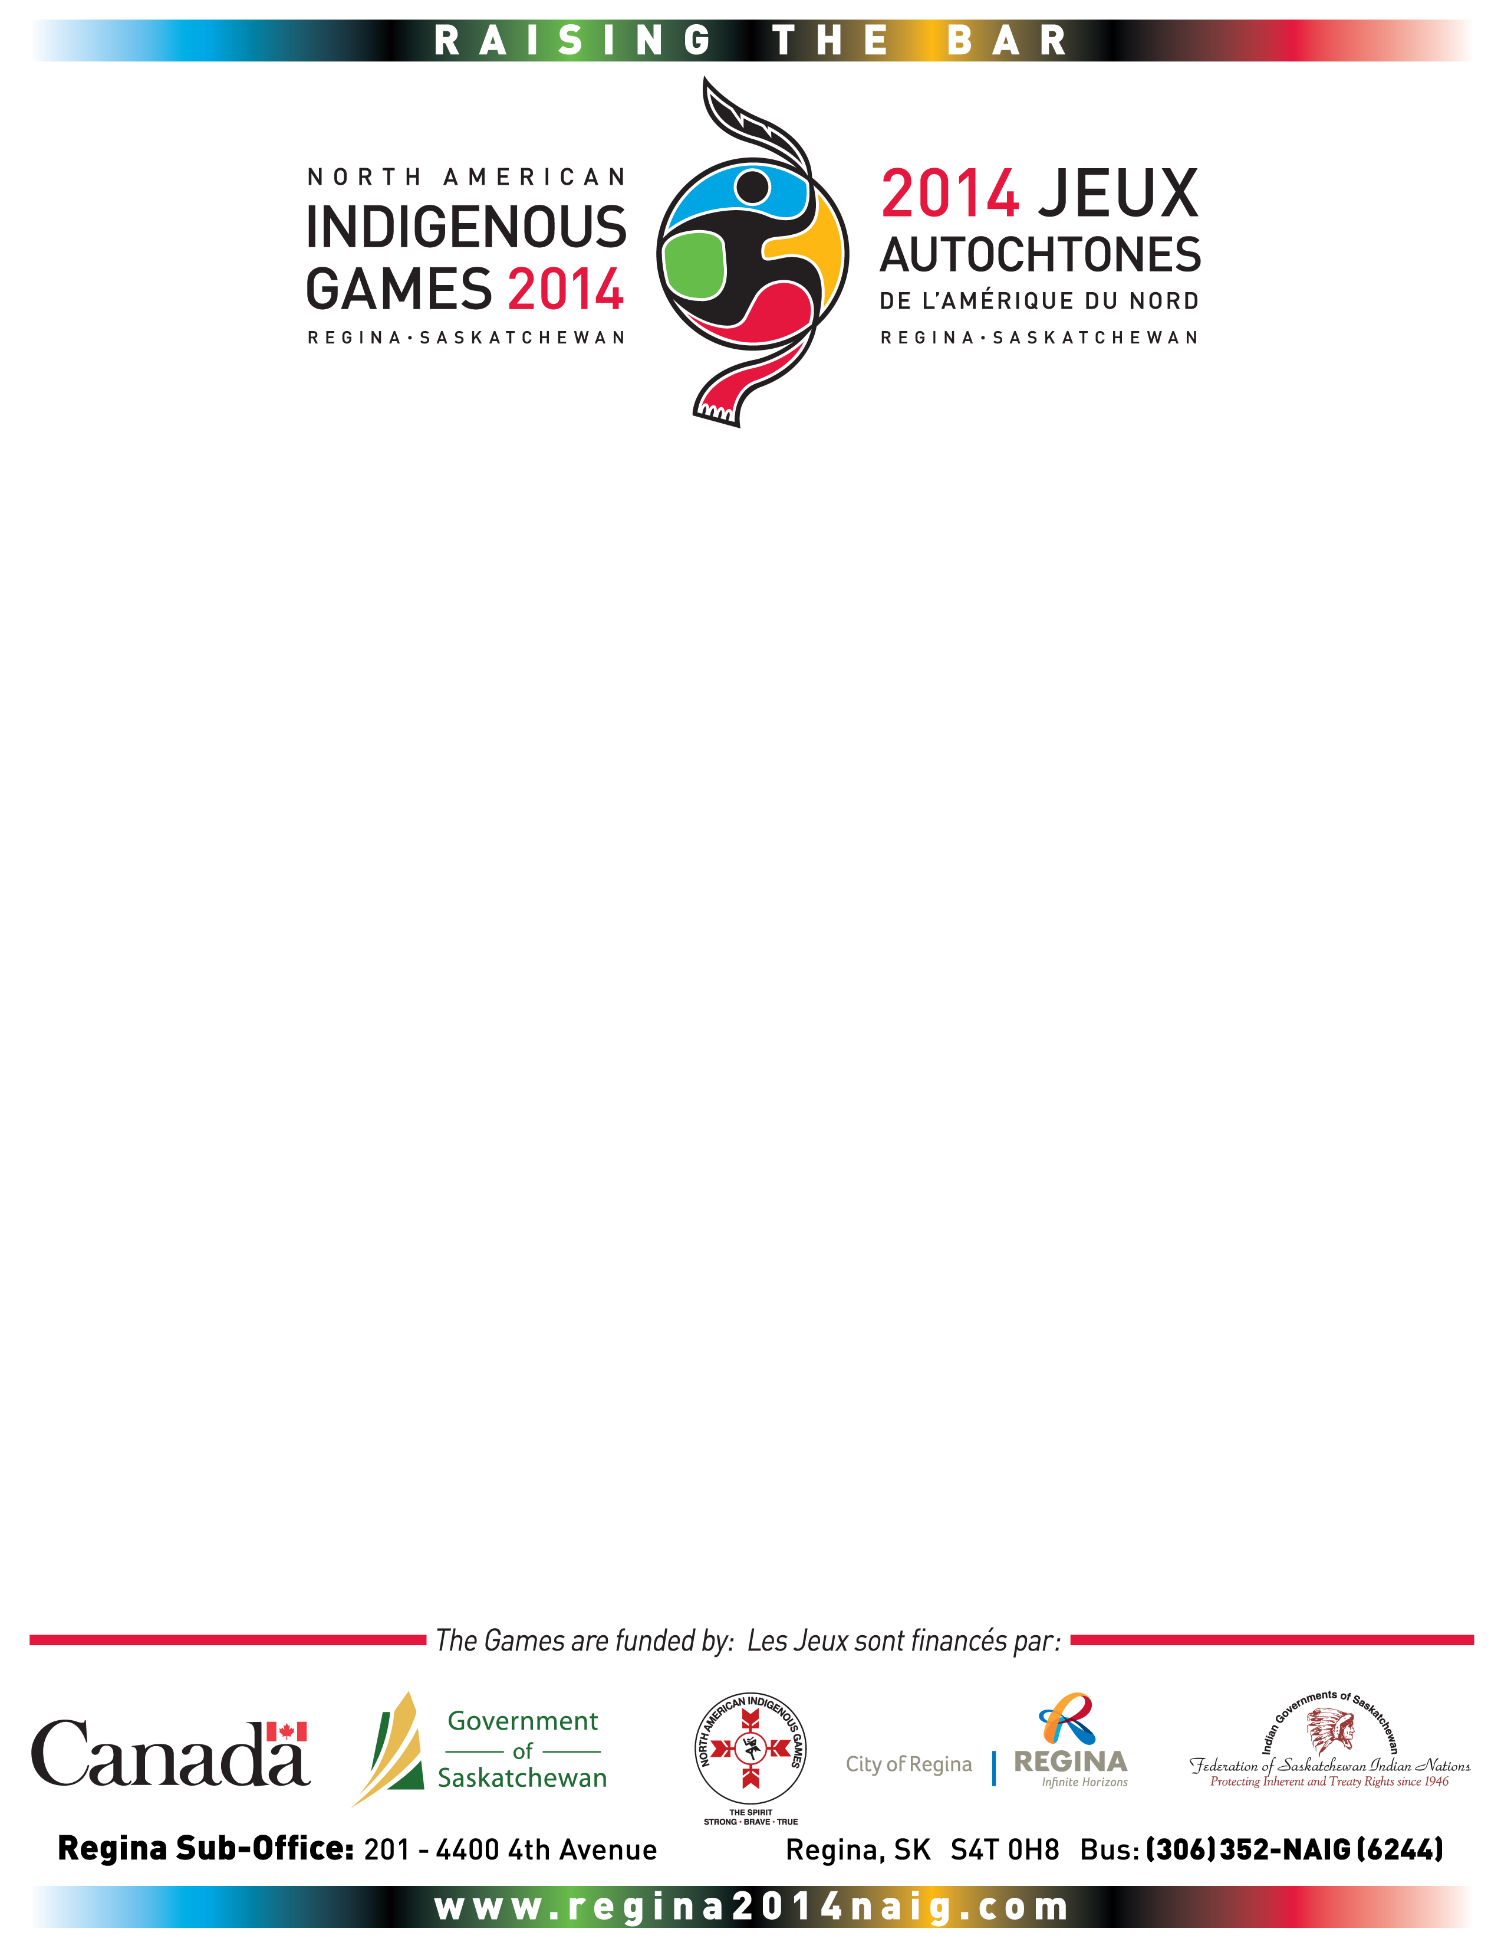

**Sport Spots Itinerary**

|  |  |  |  |
| --- | --- | --- | --- |
| **Date** | **Time** | **Events** | **Venue** |
| **Saturday, July 20th** |  |  |  |
|  | 12:45 pm | Meet at Parkdale | Parkdale Park |
| *Transportation provided* | 1:00-2:00 pm | Rifle Shooting | Fieldhouse |
|  | 2:00-2:30 pm | Lunch (provided) |  |
|  | 2:30-3:30 pm | Archery | Fieldhouse |
| **Sunday, July 21st** |  |  |  |
|  | 1:00-2:00 pm | Baseball | Parkdale Park |
|  | 2:00-2:30 pm | Lunch (provided) |  |
|  | 2:30-3:30 pm | Softball | Parkdale Park |
| **Monday, July 22nd** |  |  |  |
|  | 8:45 am | Meet at Parkdale | Parkdale Park |
| *Transportation provided* | 9:15-11:00 am | Flag Raising | City Hall |
|  | 11:30-12:00 am | Lunch (provided) | City Hall |
|  | 12:00-1:00 pm | Volleyball | Scott Gym |
|  | 2:00-3:00 pm | Badminton | Scott Gym |
| **Tuesday, July 23rd** |  |  |  |
|  | 12:45 pm | Meet at Parkdale | Parkdale Park |
| *Transportation provided* | 1:00-2:00 pm | Athletics | Wascana Park |
|  | 2:00-2:30 pm | Lunch (provided) |  |
|  | 2:30-3:30 pm | Cross Country | Wascana Park |
|  | 3:30-4:30 pm | Canoeing | Wascana Park |
| **Wednesday, July 24th** |  |  |  |
|  | 1:00-2:00 pm | Swimming | Regent Pool |
|  | 2:00-2:30 pm | Lunch (provided) |  |
|  | 2:30-3:30 pm | Golf | Regent Par 3 |
| **Thursday, July 25th** |  |  |  |
|  | 1:00-2:00 pm | Lacrosse | Grassick Park |
|  | 2:00-2:30 pm | Lunch (provided) |  |
|  | 2:30-3:30 pm | Wrestling | Grassick Park |
| **Friday, July 26th** |  |  |  |
|  | 12:45 pm | Meet at Parkdale | Parkdale Park |
| *Transportation provided* | 1:00-2:00 pm | Soccer | Mosaic Stadium |
|  | 2:00-3:00 pm | Basketball | Sportplex Outdoor Courts |
|  | 3:00-6:00 pm | BBQ (provided) | Parkdale Park |